CHAROTAR UNIVERSITY OF SCIENCE AND TECHNOLOGY (CHARUSAT)
FACULTY OF TECHNOLOGY AND ENGINEERING
SUBJECT: WEB DEVELOPMENT FRAMEWORKS (ITUE203)
SEMESTER: 3RD, 2026-27 (ODD)

Practical - 15
Final Integration, Testing, Documentation, GitHub Submission, and Local Deployment
Problem Definition: Integrate all modules into a single deployable StudentHub portal. Verify navigation, responsiveness, authentication, database operations, security checks, AJAX functionality, and documentation. Deploy locally using XAMPP/Apache virtual host and submit the GitHub repository.

A. Theory
1. What is integration testing?
Answer: Integration testing checks whether different parts of an application work together correctly. For StudentHub, this includes frontend pages, PHP handlers, database connectivity, authentication, and Fetch/AJAX features.
2. Why is end-to-end testing important?
Answer: End-to-end testing verifies a complete user journey, such as registering, logging in, viewing events, and submitting a registration. It helps find problems that may not appear when modules are tested separately.
3. What should be checked before local deployment?
Answer: Check that Apache and MySQL are running, database tables exist, configuration values are correct, all links and PHP paths work, and errors are handled safely. Test through Apache rather than opening PHP files directly from the file system.
4. Why is documentation required?
Answer: Documentation explains the project purpose, technologies, setup steps, database configuration, features, test cases, and known limitations. It helps another person install and maintain the project.
5. How should GitHub submission be maintained?
Answer: Commit working source code and documentation with clear messages, include a README and SQL export, and avoid committing passwords, database credentials, session tokens, or unnecessary generated files.
6. What is a local Apache virtual host?
Answer: A virtual host lets Apache serve a project using a custom local hostname and project-specific configuration. It can make local development URLs easier to manage.

B. Implementation / Procedure
1. Review project structure:
Check that StudentHub pages, CSS, JavaScript, PHP handlers, database connection file, upload folders, and README are organized consistently. Remove unused test files and keep configuration separate from public-facing files where possible.
2. Configure the database:
Start Apache and MySQL in XAMPP. Import the SQL dump through phpMyAdmin, verify required tables and relationships, and check that the PHP database connection uses the correct database name and credentials.
3. Integrate navigation and UI:
Open each page through localhost and test navigation menus, forms, buttons, responsive layout, and links. Check desktop and mobile widths and fix broken paths or inconsistent layouts.
4. Test registration and authentication:
Test valid registration, invalid input, duplicate email, password hashing, successful login, incorrect password, logout, session timeout, and role-based access. Confirm protected pages reject unauthorized users.
5. Test database modules:
Test student and event CRUD operations, search and filters, poster upload restrictions, and database error handling. Confirm inserts, updates, and deletes are reflected in the database and interface.
6. Test JSON API and Fetch:
Use browser Developer Tools Network tab to inspect requests and JSON responses. Test list, create, update, and delete operations and verify loading, success, and error states work without a full page reload.
7. Security and accessibility review:
Check prepared statements, server-side validation, escaped output, role checks on protected pages, safe file uploads, CSRF protection where implemented, accessible labels, keyboard navigation, and meaningful image alt text.
8. Prepare documentation and repository:
Update README.md with project overview, features, requirements, installation steps, database import instructions, configuration, test cases, and known limitations. Export the database schema and seed data as SQL. Review files before committing.
9. Deploy locally:
Place the project inside the XAMPP web directory and test it through Apache. For the optional virtual-host extension, configure the Apache virtual host and local hosts-file entry, restart Apache, and verify the local hostname.
10. Final verification:
Run main test cases again from a clean browser session, capture screenshots, check for PHP and browser-console errors, and confirm the repository contains the final source code and documentation.

C. Final Testing Checklist
Test Area | Test / Action | Expected Result
Navigation | Open each page and follow all main links | All pages load and links work
Responsive layout | Check desktop, tablet, and mobile widths | Content remains readable without unwanted overflow
Registration | Test valid, invalid, and duplicate registration | Validation works and passwords are hashed
Login/logout | Test correct and incorrect credentials, then logout | Authentication and session handling work
Role-based access | Open admin pages as a student user | Unauthorized access is blocked
Student CRUD | Add, view, edit, delete, search, and filter | Changes persist and results are accurate
Event CRUD/upload | Create/update/delete event and test poster types/sizes | CRUD works and invalid uploads are rejected
Fetch API | List and modify records using asynchronous requests | JSON responses are valid and page does not reload
Database | Inspect tables and relationships in phpMyAdmin | Expected records and relationships exist
Deployment | Open project through localhost or configured virtual host | Application is served correctly by Apache
GitHub/documentation | Review README, SQL export, and repository files | Submission is complete and contains no secrets

D. Key Questions / Analysis / Interpretation
1. Are all pages properly linked and navigable?
Answer: Every page should be reachable through the intended navigation flow, and internal links should use correct paths.
2. Are sessions, roles, validations, and database operations working end-to-end?
Answer: Test complete workflows, not only isolated functions. For example, a student must not access an admin-only action by typing its URL directly.
3. Are security and accessibility checklists completed?
Answer: Confirm server-side validation, prepared statements, output escaping, session protections, safe uploads, accessible labels, keyboard support, and readable contrast.
4. Is project documentation sufficient for installation and testing?
Answer: README should describe requirements, setup, database import, configuration, core features, test cases, and known limitations clearly enough for another developer to reproduce the setup.
5. Is the project repository clean and properly committed?
Answer: The repository should contain source files, documentation, and SQL export, with clear commit messages and without passwords, private credentials, or unnecessary temporary files.

M. Evidence of Work (Screenshots)
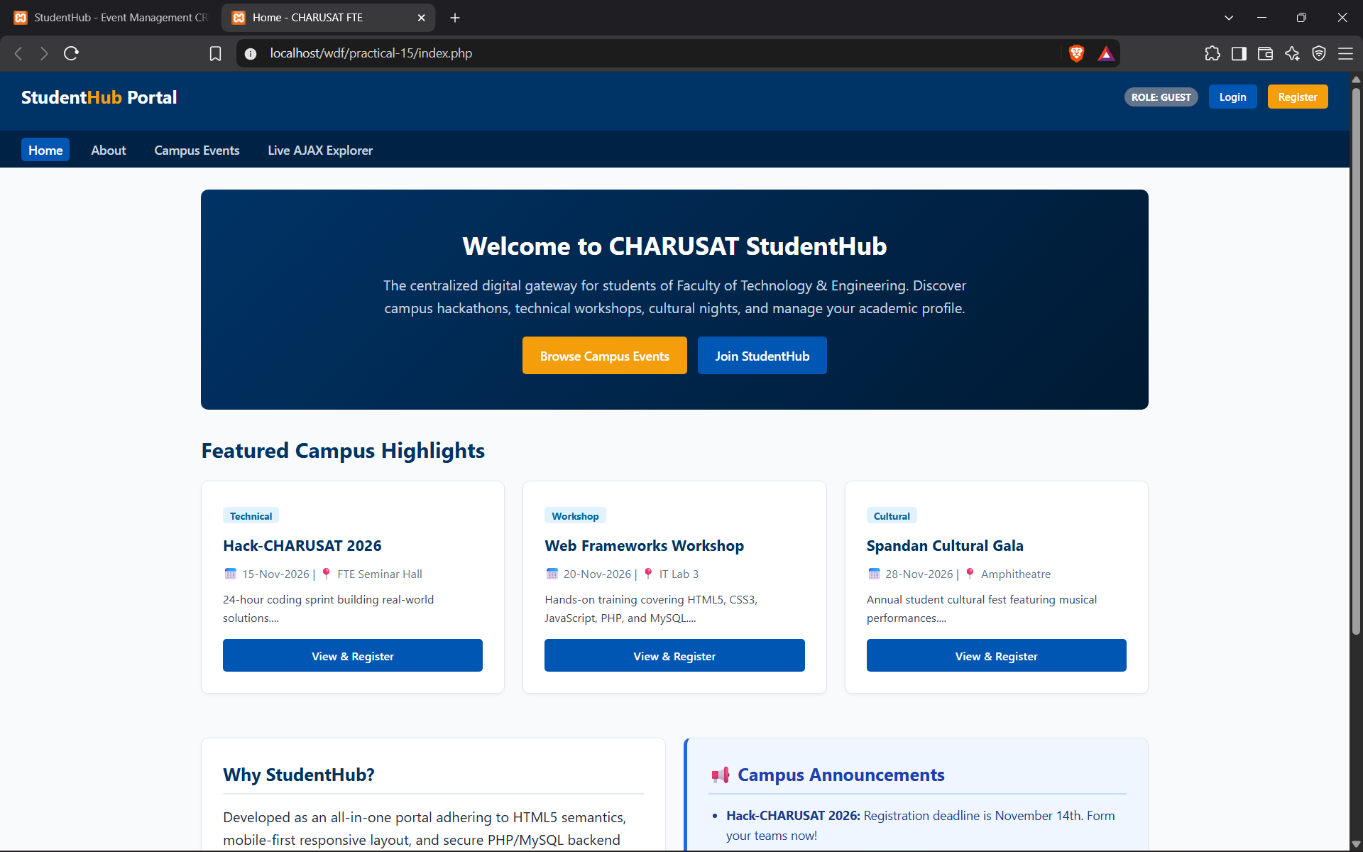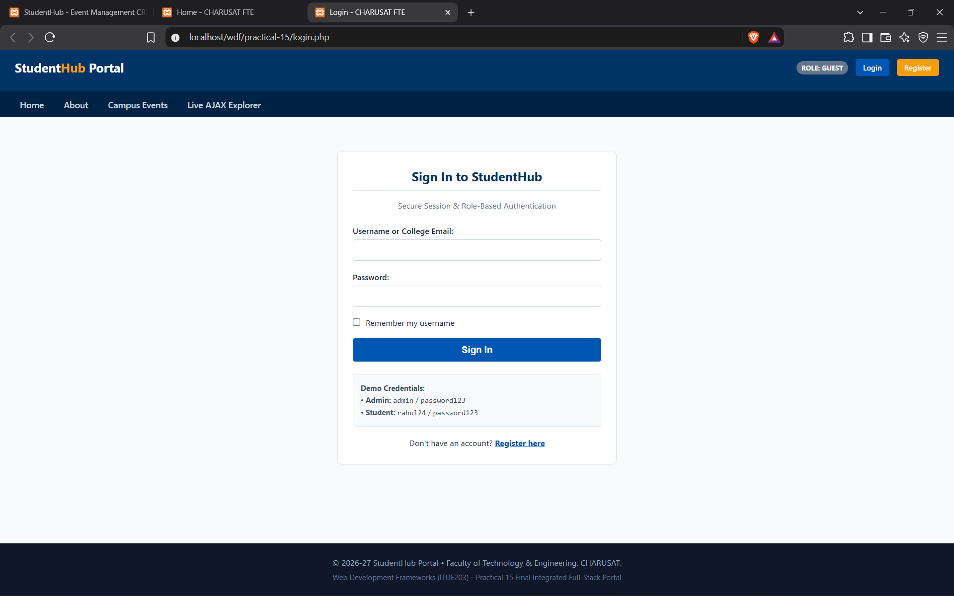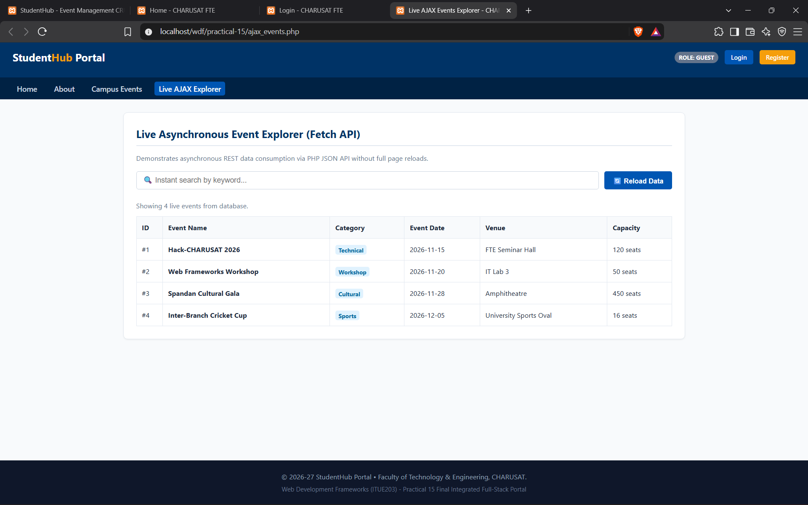

N. GitHub Repository Link
https://github.com/duttprajapati/Wdf

Faculty Remarks

